CS 482 Homework 4 Talha Agcayazi

**P1:**

**a)**

**b)**

**P2:**

**P1:**

Input Histogram OTSU Recursive

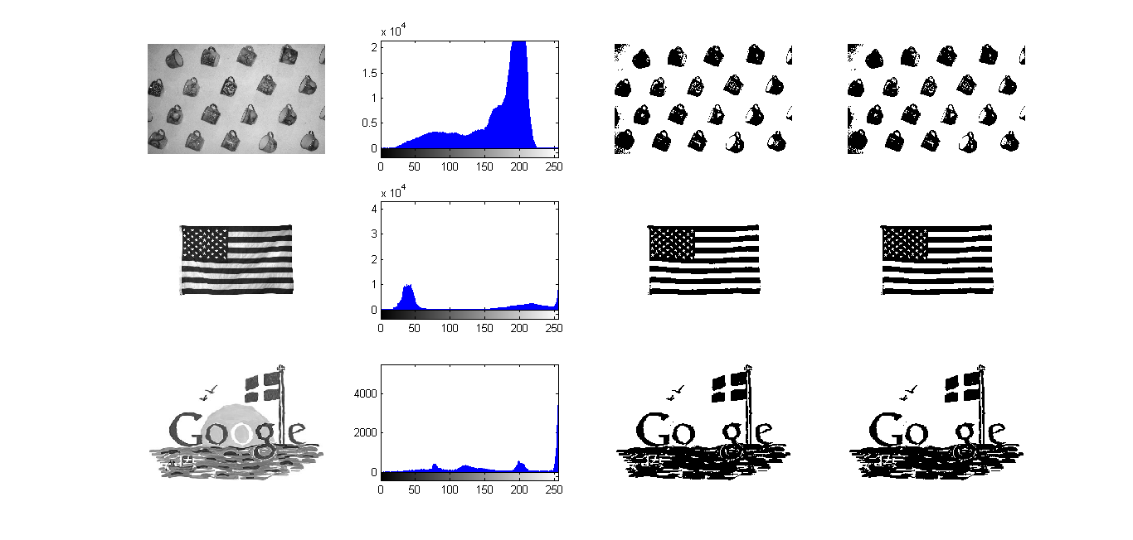

**otsutime = 0.0049**

**rectime = 0.0058**

**P2:**

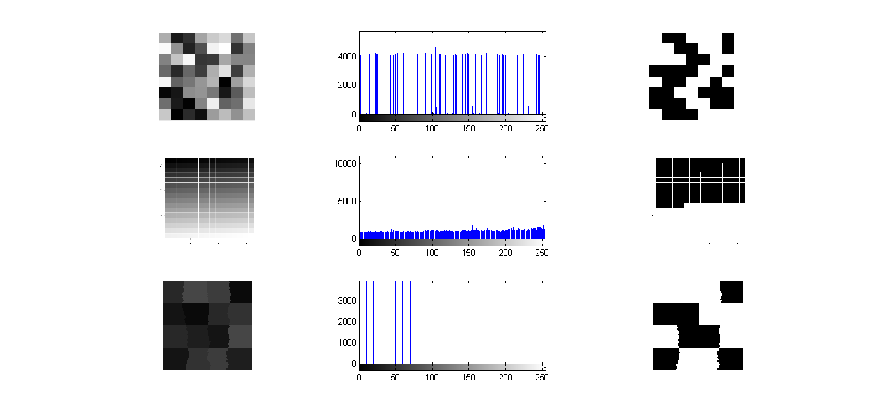

Input Histogram OTSU result

otsutime = 0.0017

rectime = 0.0030

Code:

P1:

% 1. Apply Otsu threshold method to 3 (three) different B/W images using (a) textbook algorithm;

% and (b) recursion equations. Display outputs and compare timing for both methods.

% 2. Expand on Otsuâ€™ binarization method to 3 (three) different B/W images consisting of several non-overlapping

% objects of almost constant but different gray-level.

% Report includes (a) flow-chart of (input-output) stepwise methods used;(b1) histograms for input B/W images;

% (b2) input-output displays; (c) timing; and (d) MATLAB code.

%image reference 2nd: http://www.usaflagsupply.com/

M1 = imread('M1.JPG');

M2 = imread('M2.JPG');

M3 = imread('M3.PNG');

M1 = rgb2gray(M1);

M2 = rgb2gray(M2);

M3 = rgb2gray(M3);

tic;

M1l = graythresh(M1);

M2l = graythresh(M2);

M3l = graythresh(M3);

otsutime = toc

tic

M1lr = otsurec(M1, 1);

M2lr = otsurec(M2, 1);

M3lr = otsurec(M3, 1);

rectime = toc

BW1 = im2bw(M1, M1l);

BW2 = im2bw(M2, M2l);

BW3 = im2bw(M3, M3l);

BW1r = im2bw(M1, M1lr);

BW2r = im2bw(M2, M2lr);

BW3r = im2bw(M3, M3lr);

figure();

subplot(3,4,1)

imshow(M1)

subplot(3,4,5)

imshow(M2)

subplot(3,4,9)

imshow(M3)

subplot(3,4,2)

imhist(M1);

subplot(3,4,6)

imhist(M2);

subplot(3,4,10)

imhist(M3);

subplot(3,4,3)

imshow(BW1);

subplot(3,4,7)

imshow(BW2);

subplot(3,4,11)

imshow(BW3);

subplot(3,4,4)

imshow(BW1r);

subplot(3,4,8)

imshow(BW2r);

subplot(3,4,12)

imshow(BW3r);

P2

% 1. Apply Otsu threshold method to 3 (three) different B/W images using (a) textbook algorithm;

% and (b) recursion equations. Display outputs and compare timing for both methods.

% 2. Expand on Otsuâ€™ binarization method to 3 (three) different B/W images consisting of several non-overlapping

% objects of almost constant but different gray-level.

% Report includes (a) flow-chart of (input-output) stepwise methods used;(b1) histograms for input B/W images;

% (b2) input-output displays; (c) timing; and (d) MATLAB code.

%image reference 1st: http://bobbycorpus.files.wordpress.com/2012/01/sample_gray_levels.png

%image reference 2nd: http://bobbycorpus.files.wordpress.com/2012/01/levels_of_gray.png

%image reference 3rd: http://scien.stanford.edu/pages/labsite/2000/psych221/projects/00/trek/CameraGamma.html

M1 = imread('G1.JPG');

M2 = imread('G2.JPG');

M3 = imread('G3.JPG');

M1 = rgb2gray(M1);

M2 = rgb2gray(M2);

tic;

M1l = graythresh(M1);

M2l = graythresh(M2);

M3l = graythresh(M3);

otsutime = toc

tic

M1lr = otsurec(M1, 1);

M2lr = otsurec(M2, 1);

M3lr = otsurec(M3, 1);

rectime = toc

BW1 = im2bw(M1, M1l);

BW2 = im2bw(M2, M2l);

BW3 = im2bw(M3, M3l);

BW1r = im2bw(M1, M1lr);

BW2r = im2bw(M2, M2lr);

BW3r = im2bw(M3, M3lr);

figure();

subplot(3,3,1)

imshow(M1)

subplot(3,3,4)

imshow(M2)

subplot(3,3,7)

imshow(M3)

subplot(3,3,2)

imhist(M1);

subplot(3,3,5)

imhist(M2);

subplot(3,3,8)

imhist(M3);

subplot(3,3,3)

imshow(BW1);

subplot(3,3,6)

imshow(BW2);

subplot(3,3,9)

imshow(BW3);